Section | Description | Author
Background Context | Project description from catalog  Company background | Leave until the end
Outcome | - Description of problem by organization (see slides or meeting minutes)  - Goal of project - a functioning prototype  - Outcome for organization upon meeting goals | Wency
Deliverables | - Azure User Interface  - Weight sensor module ( Melika)  - Wireless data transfer ( Melika)  - Transmitting end  - Receiving end  - Technical constraints (Adil)  - Configuration ( Adil)
Budget | - Weight sensor (Wency)  - Raspberry pi ( Melika)  - Ethernet cables  - 9 V batteries  - Jumper wires  - Breadboards  - $100 for Azure credit  - https://docs.google.com/spreadsheets/d/1MA3cPp3Cs94ub7PX6WQADn8suKP0_yOthGd1qX7urbE/edit#gid=0 | - Weight sensors with mg sensitivity  - Raspberry Pi  - Costs associated with Azure
Project Management | Milestones - timeline  Risks and dependencies  Roles and responsibilities  Individual team member expectations  Conflict Resolution | Ammar
Questions for shawn;
- Do you have raspberry pi modules? We need minimum 2
- Would you be able to provide azure account? We’re having a hard time getting the Azure student account because we’re a canadian university

Things to discuss :
- The modularization of the product
  - Need a visual
- Using open source code minicloud
- The emphasis of the design should be more around the hardware part?
- Considerations for integrating this project with the rest of their system
- Scalability considerations : different products, possibly more sensors, anything else?

  - 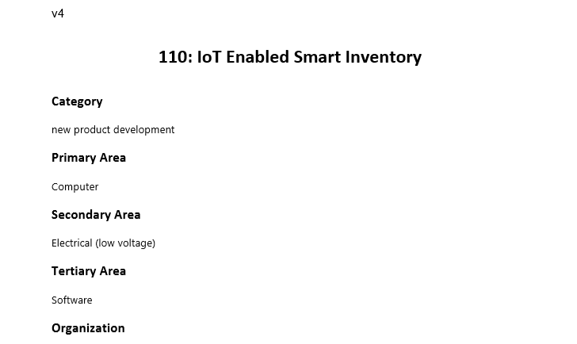
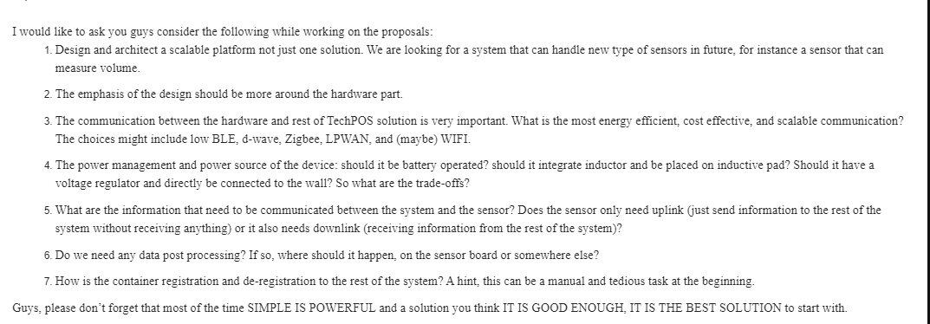

Action items ;

- Account open
- Get azure student Oct 21st
- Gather all components from previous project courses
- Bring lock for locker 110 mcld 458

